Curriculum Vitae
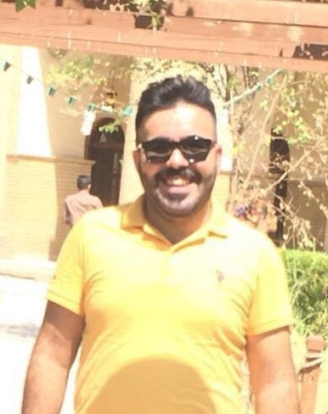

Ali Taha Yassin |  |  | Name
Iraq/Baghdad/alsaydia |  |  | Home Address
11/4/1993 | Birth Date | baghdad | Place of Birth
male | Gender | single | Marital status
muslim | Religion | iraqi | Nationality

Financial and banking science | College or institute | Dijla university college | University Name
2016-2015 | Graduation year |  | Specialization
 |  |  | Specialty

 | 009647714636719 | Phone number
aliobaeidi@gmail.com |  | E.MAIL

Worked as a store manager with Bahar group(DLC) for two years  عملت مدير مخزن لدى بهار كروب (DLC) للاجهزة الكهربائية |  |  |  | Experiences
Work on alameer accounting program  اجيد العمل على برنامج الامير للحسابات |  |  |  | Skills
Writing | Reading | Talk | Language | Languages
Good | Good | Good | English | Languages
Very good | Very good | Very good | Arabic | Languages
 |  |  | Other language | Languages

